Program Documentation

Design and Deployment of

The implementation of Single and Doubly Linked Lists

Project Assignment 1 – Final Program

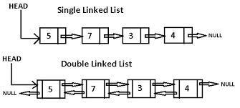

CS 250 – Data Structures and Algorithms in C++

By: Bernadette Slack

February 2020

**Table of Contents**

1. Basic concept of program development……………………………………….………..3
2. Sources……………………………………………………………………….………....4
3. Source Code………………………………………………………………….……...5-12
   1. Main…………………………………………………………………………….5
   2. Singly Linked List………………………………………………….…………..8
   3. Doubly Linked List…………………………………………………....………12
4. Code in Action………………………………………………………….…………16-24
   1. Singly Linked List………………………………………………………....…16
   2. Doubly Linked List……………………………………………….………..…21

**Basic Concept**

For my project I started with the linked list class from our textbook1. The implementation of main was done with my audience in mind, that of a professional familiar with using linked lists and the language of C++. I in main I chose to use cascading if statements to cover my options menu inside of a Do-While loop (to ensure the user gets access to the menu at least once). To implement the search and output of the address of a node I found an example of traversing a linked list from GeeksforGeeks2, I modified this code to work with the skeleton from the book. For putting together the pieces of inserting a node I found Code Mentor’s3 comprehensive linked list explanations and examples. I used a combination of the algorithms from the slides4, the book, and these two websites to put together the single linked list. The code fragments along with a flowchart / mind map to connect all the functions, pointers and main to achieve the project requirements. Because this project is far from being an achievement of my own abilities, below are a list of sources used to build my class and the member functions.

With the development of the doubly linked list I used the basic structure from my linked list modifying the nodes to match the node class in our text book1, using the direction in the slides4 to modify the singly linked list to become a doubly linked list. Below in this document are the screen shots of my program in action. The body of main is roughly the same for both implementations of the linked list since they both are being manipulated according to the same set of instructions per our program directions.

**Sources:**

1. Drozdek, Adam. Data Structures and Algorithms in C++, Cengage Learning, 2013
2. <https://www.geeksforgeeks.org/write-a-function-to-get-nth-node-in-a-linked-list/>
3. <https://www.codementor.io/@codementorteam/a-comprehensive-guide-to-implementation-of-singly-linked-list-using-c_plus_plus-ondlm5azr>
4. Slides from CS250 curtesy of Dr. Wu.

**Source Code – Main**

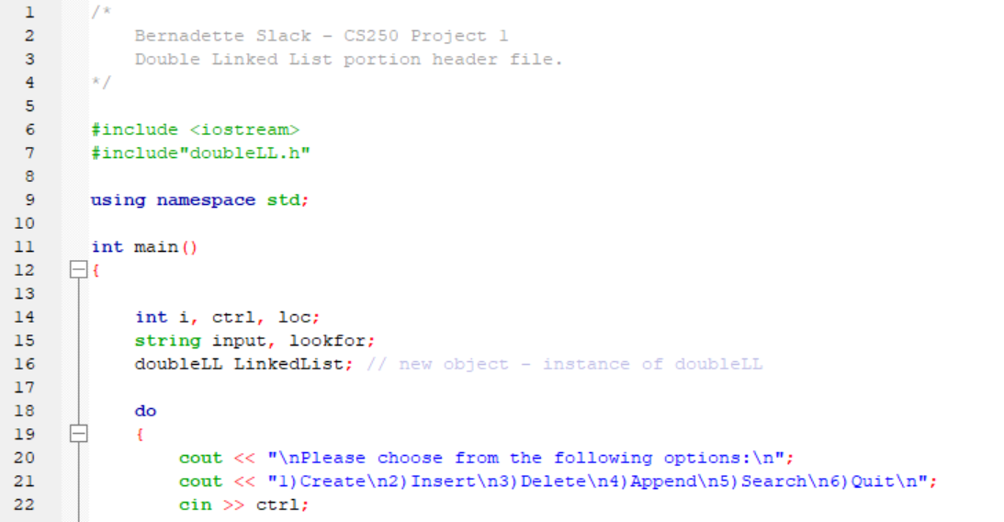

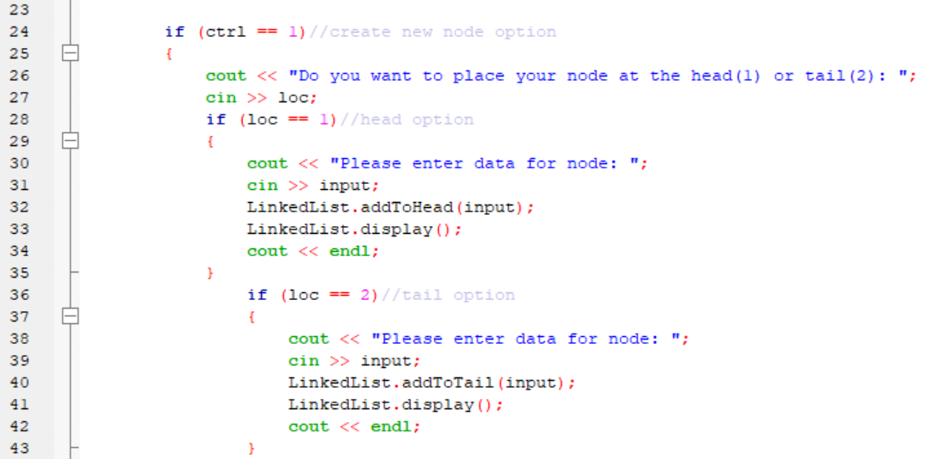

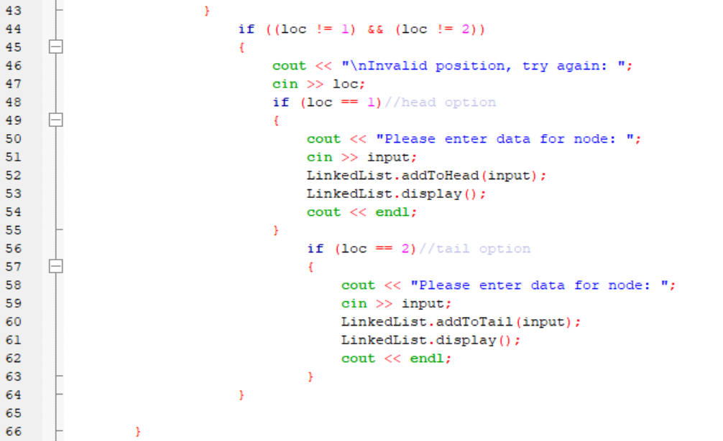

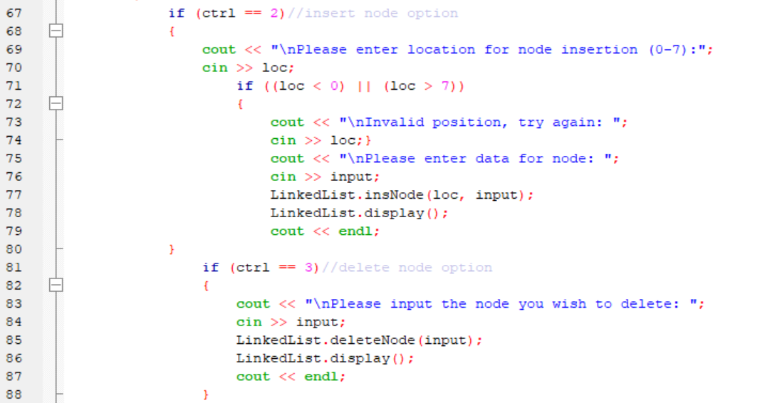

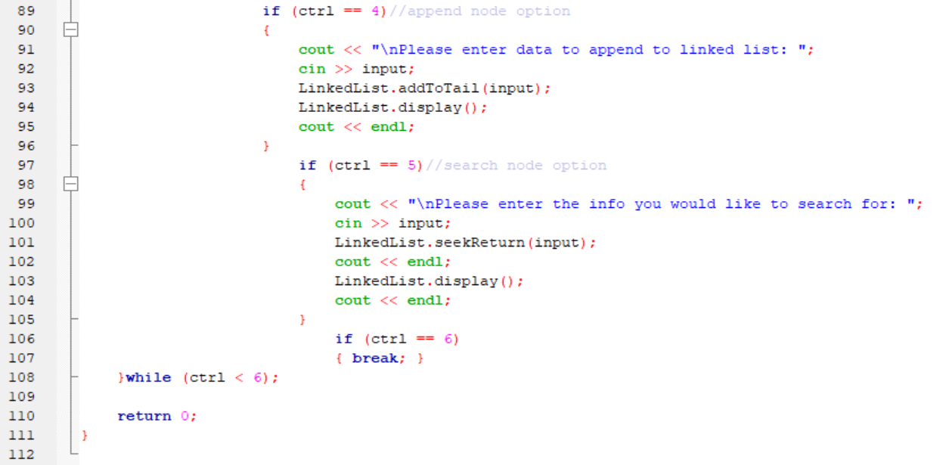

**Source Code – Singly Linked List Header**

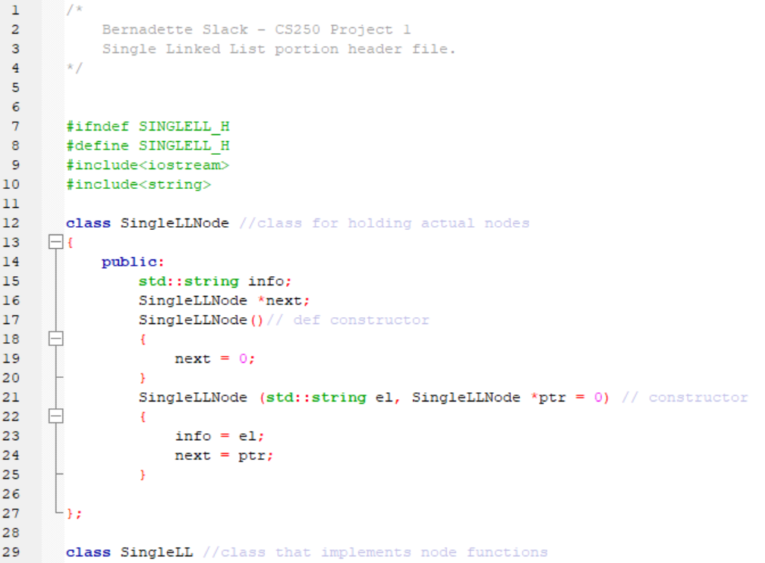

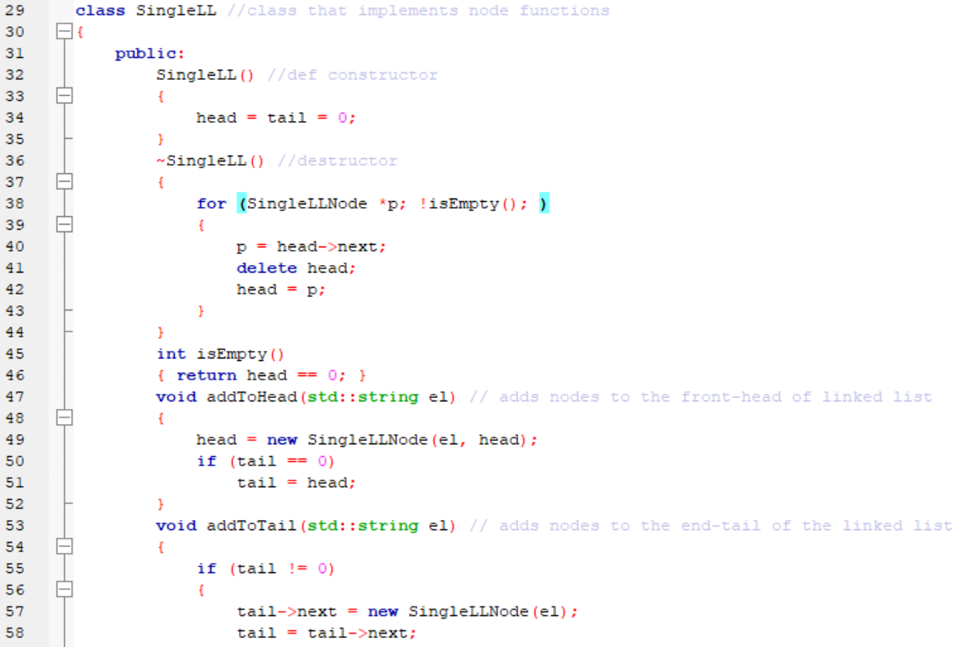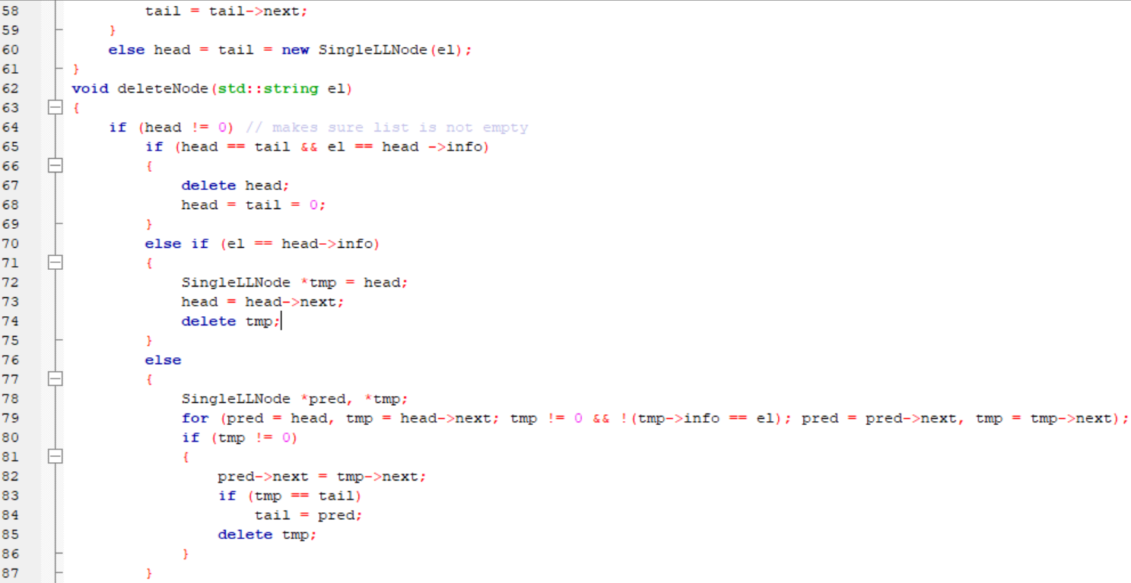

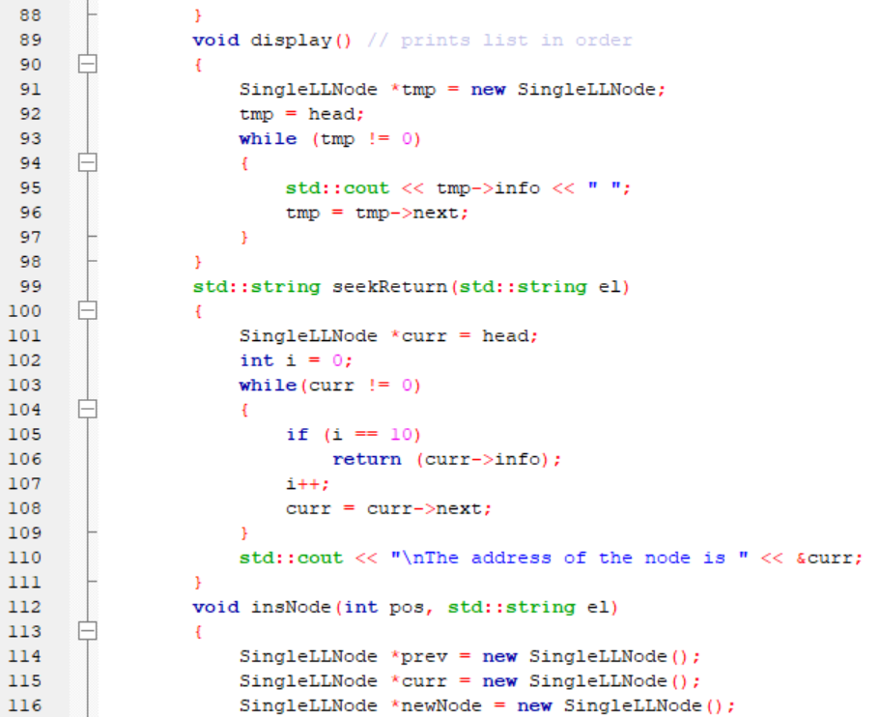

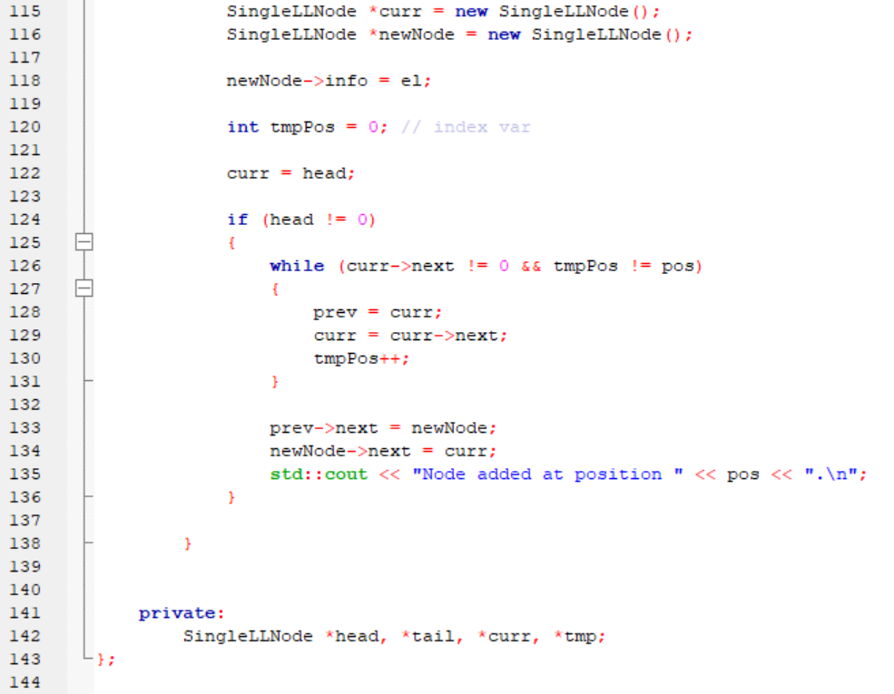

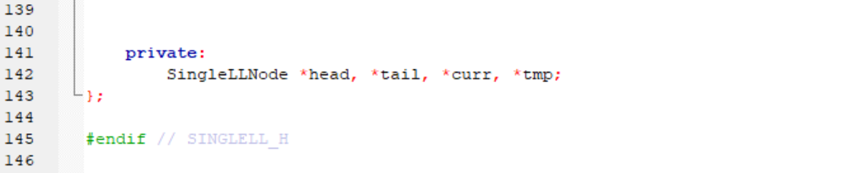

**Source Code - Doubly Linked List Header**

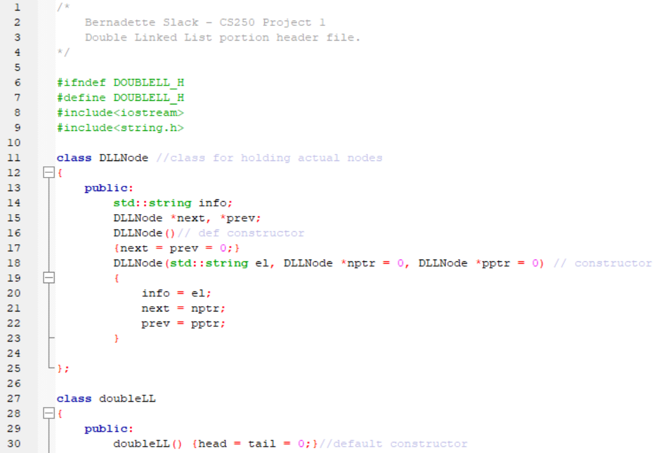

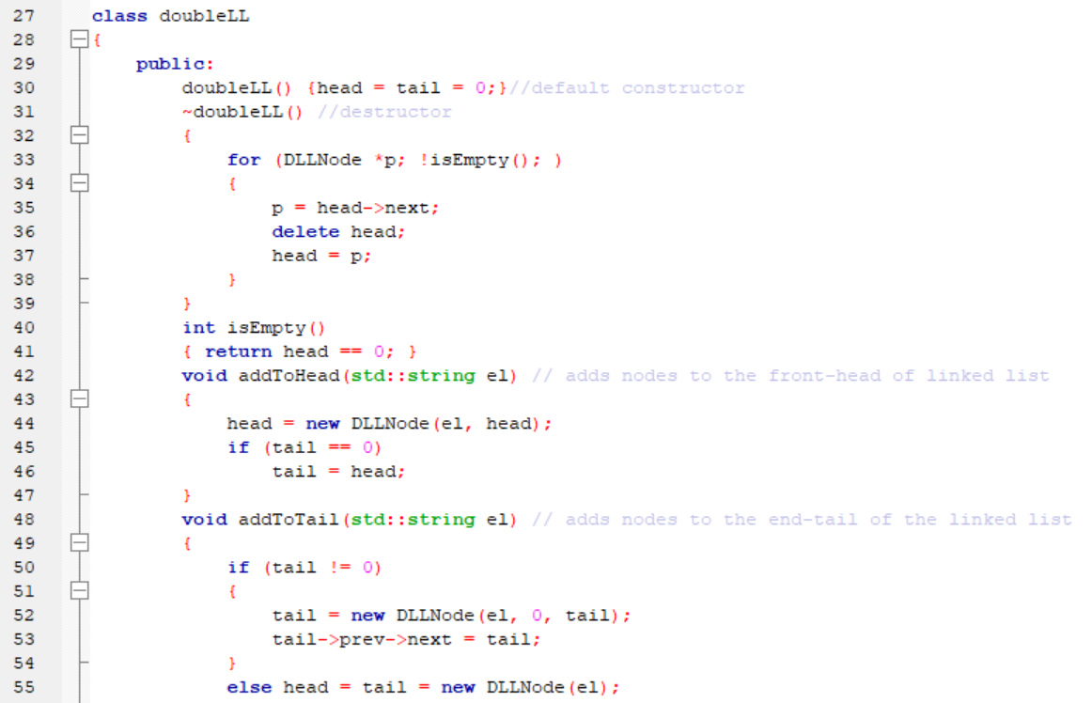

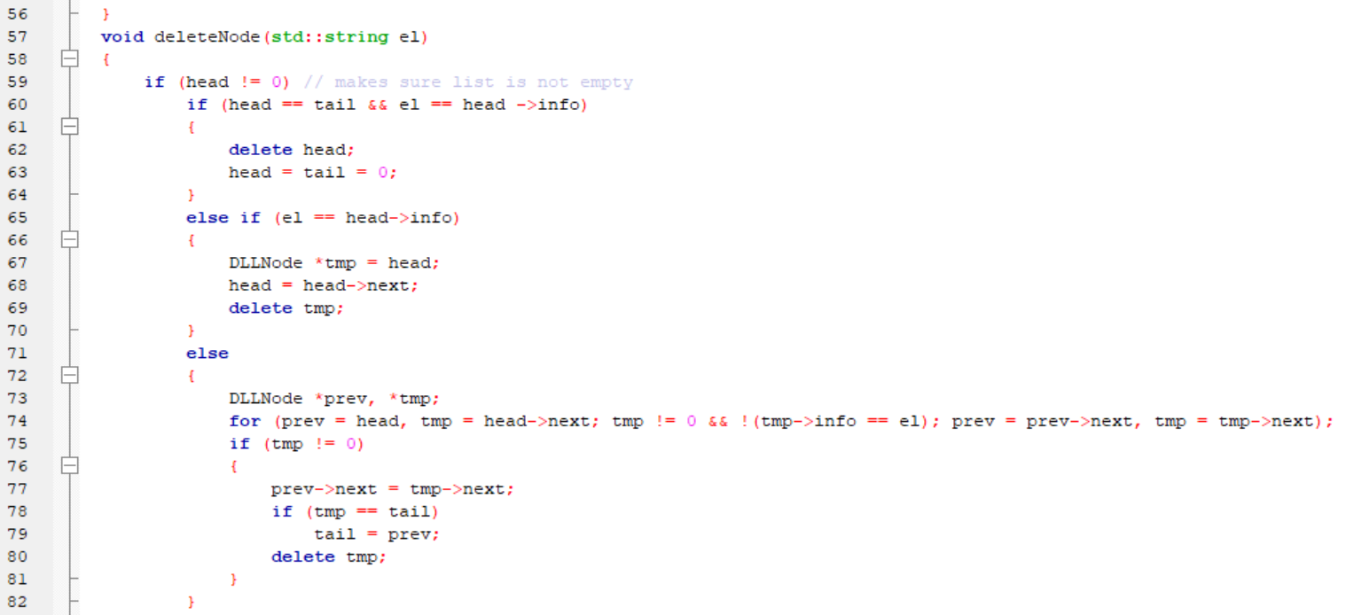

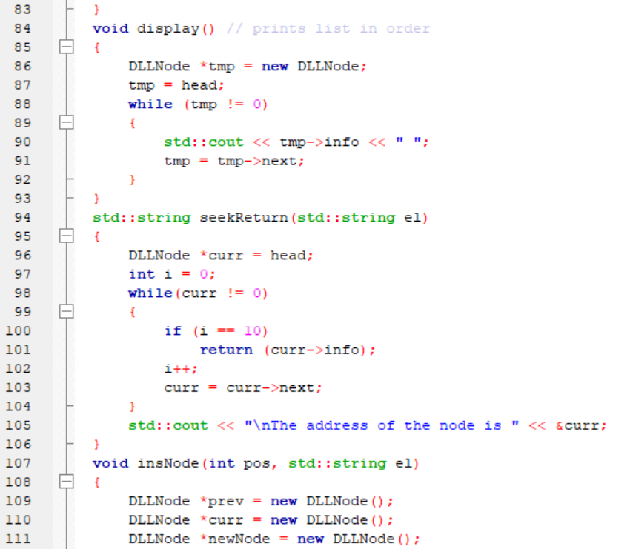

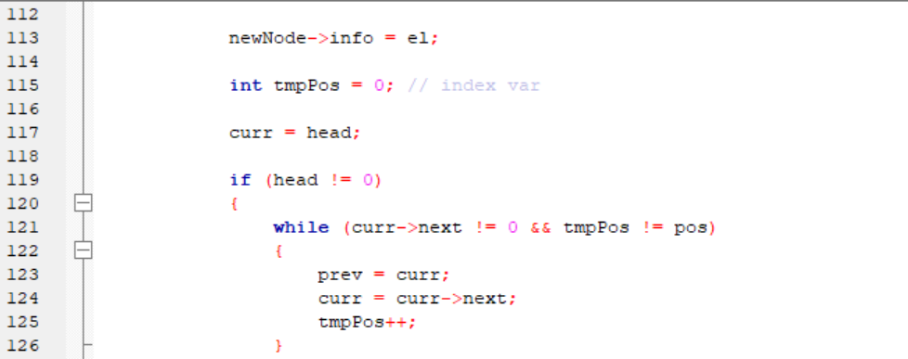

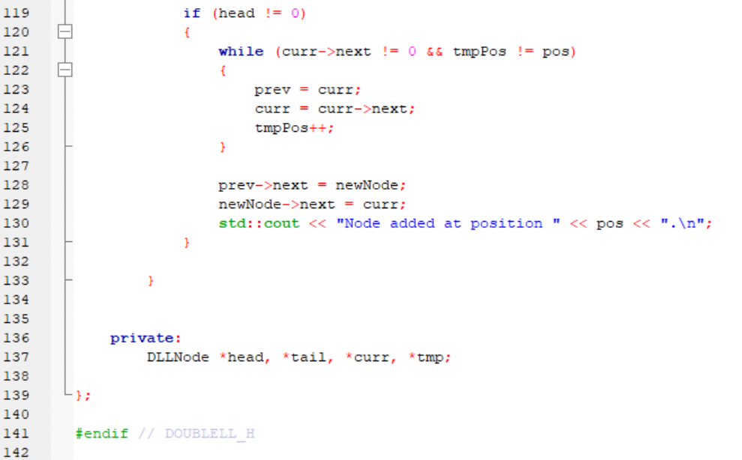

**Singly Linked List – Execution**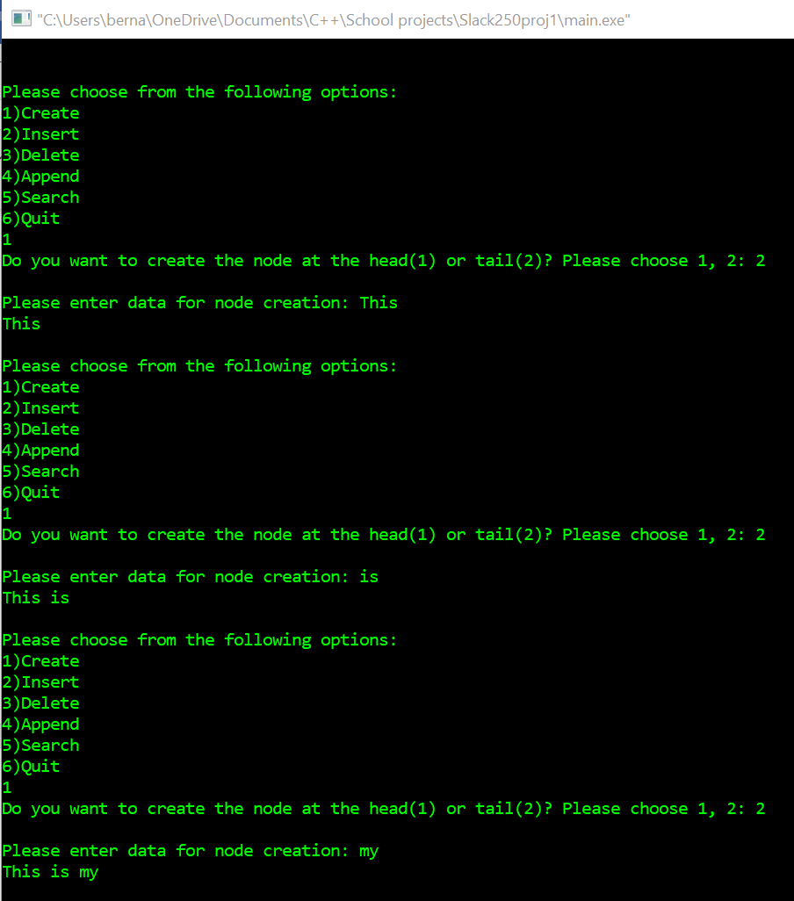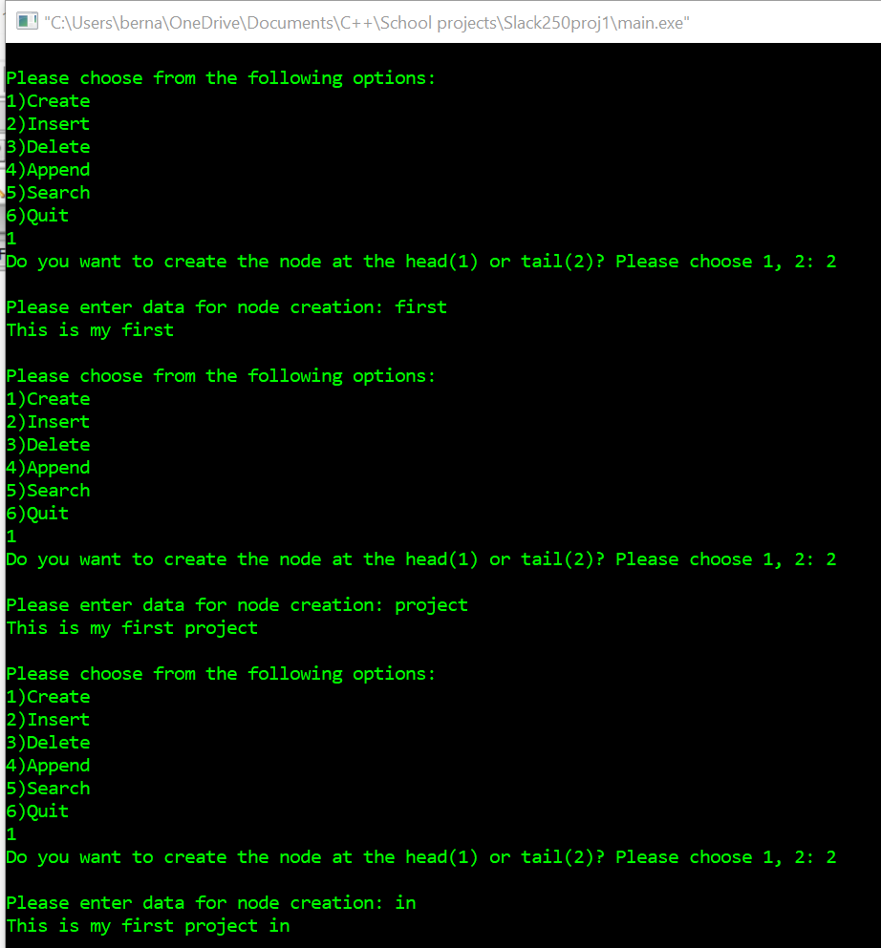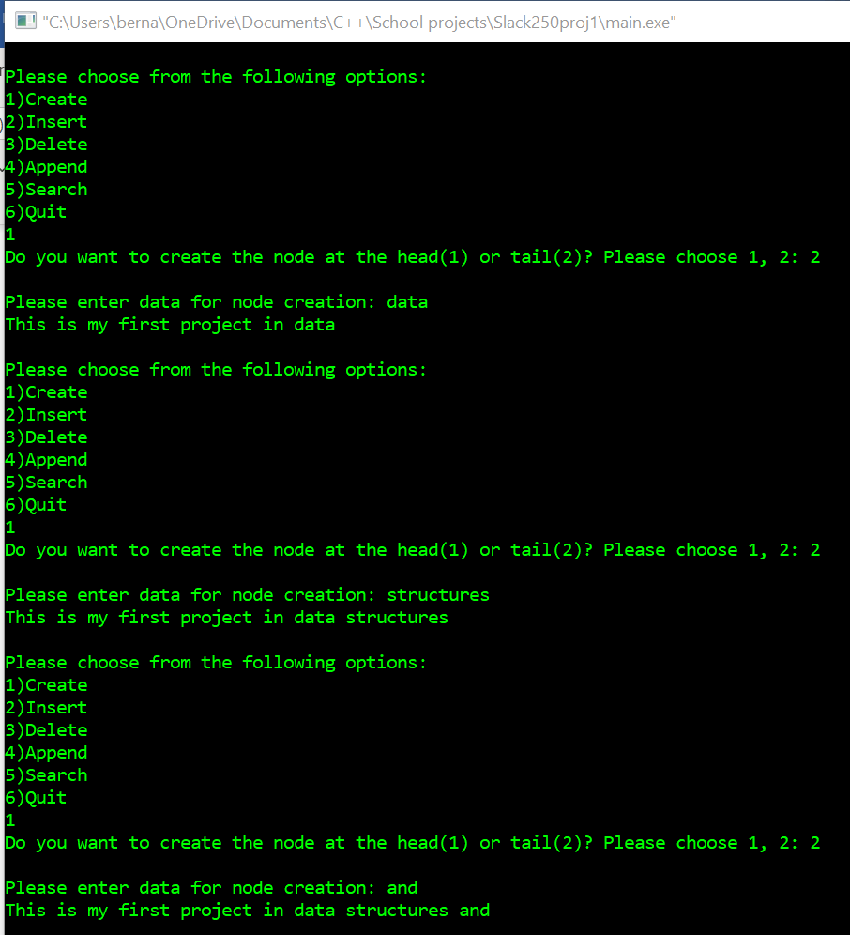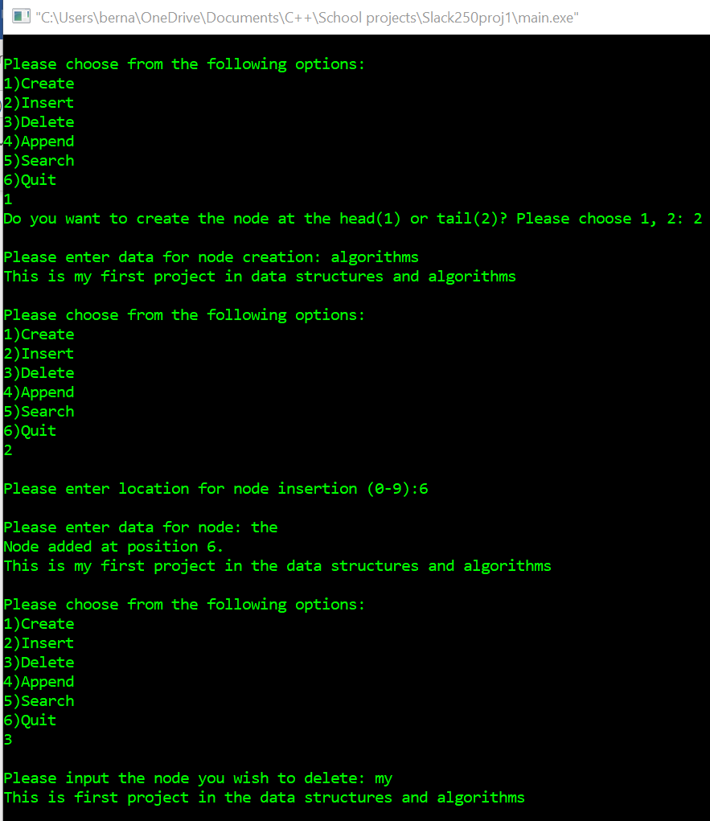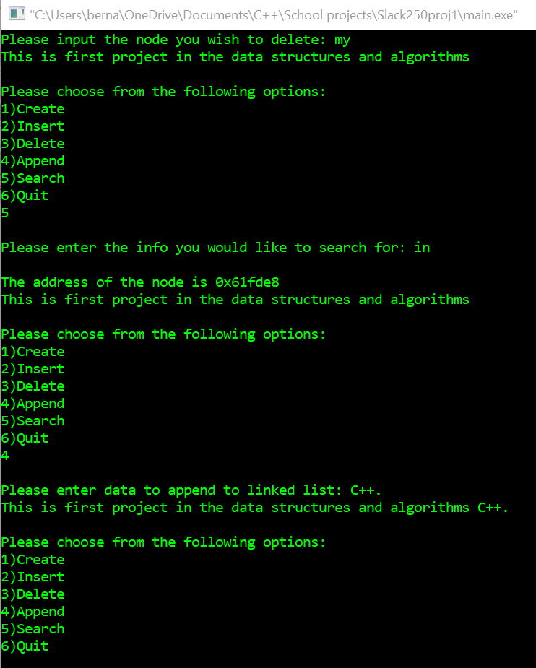

**Doubly Linked List – Execution**

